Question: In an educational institute, various numbers of courses are offered. In each course, 7 numbers of subjects are taught. One student can select minimum 5 and maximum 6 numbers of subjects for that course. Each course has maximum intake capacity. The same subject may be taught in various courses. The system must be able to handle course, subject, student, marks grade and enrollment information. Assumptions also can be made. Design an ER diagram and database schema for the system. Specify the primary key, foreign key and other constraints for all required tables. Draw the ER diagram in MS Word.

ER Diagram

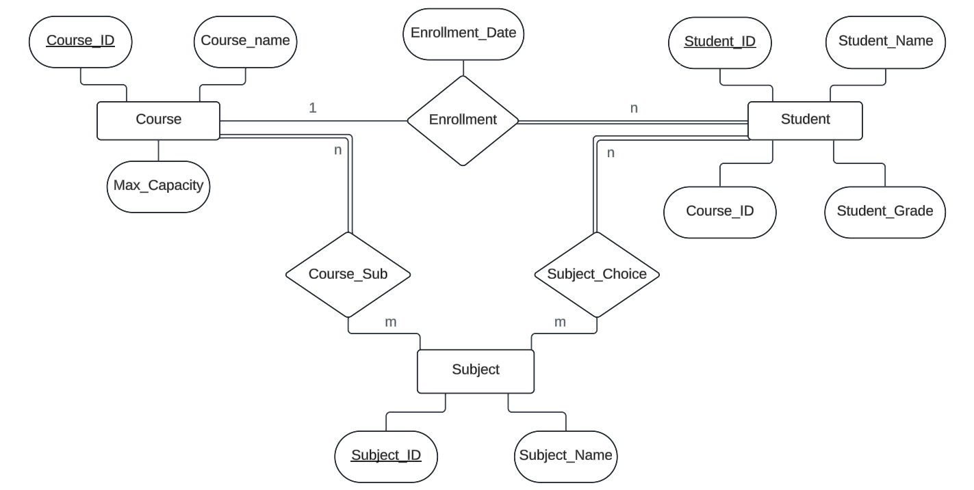

Database Schema

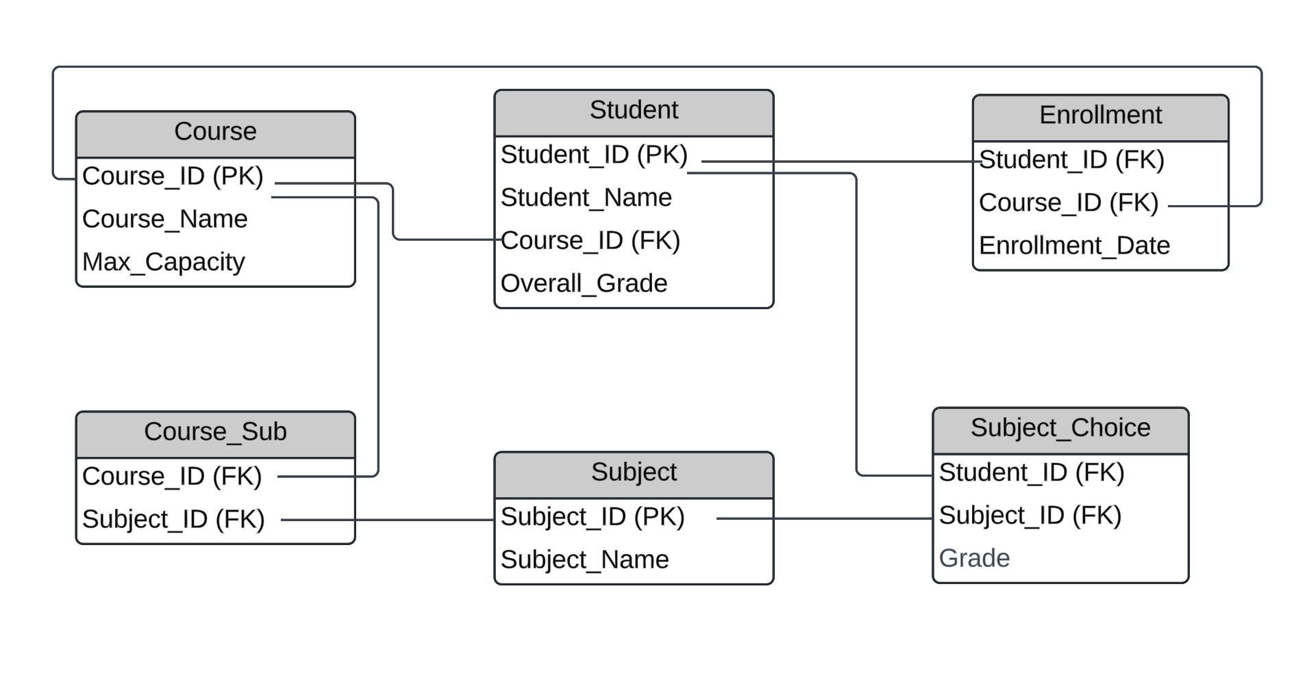

1. **Insert at least five tuples in each table.**

-- COURSE Table

Create Table COURSE (COURSE_ID number (2) PRIMARY KEY, COURSE_NAME varchar2(10), MAX_CAPACITY number (3));

Insert into COURSE values (10, 'CS', 100);

Insert into COURSE values (20, 'IT', 90);

Insert into COURSE values (30, 'ECE', 125);

Insert into COURSE values (40, 'EE', 85);

Insert into COURSE values (50, 'IEE', 90);

--SUBJECT Table

Create Table SUBJECT (

SUBJECT_ID number (3) PRIMARY KEY, SUBJECT_NAME varchar2(15));

Insert into SUBJECT values (101, 'DBMS');

Insert into SUBJECT values (102, 'OOP');

Insert into SUBJECT values (103, 'DSA');

Insert into SUBJECT values (104, 'MATHS');

Insert into SUBJECT values (105, 'ELECTRONICS');

Insert into SUBJECT values (106, 'COA');

Insert into SUBJECT values (107, 'PHYSICS');

Insert into SUBJECT values (108, 'CHEMISTRY');

--STUDENT Table

Create Table STUDENT (

STUDENT_ID number (5) PRIMARY KEY, STUDENT_NAME varchar2(25), COURSE_ID number (2), OVERALL_GRADE varchar2(1), FOREIGN KEY(COURSE_ID) REFERENCES COURSE(COURSE_ID));

Insert into STUDENT values (18050, 'DEBODIT', 10, 'B');

Insert into STUDENT values (18051, 'SOHAM', 20, 'A');

Insert into STUDENT values (18052, 'ANUSKA', 30, 'C');

Insert into STUDENT values (18053, 'PRAMA', 20, 'B');

Insert into STUDENT values (18054, 'RISHIKA', 10, 'A');

Insert into STUDENT values (18055, 'ANISH', 40, 'A');

Insert into STUDENT values (18056, 'DANIAL', 20, 'C');

Insert into STUDENT values (18057, 'PRAGYA', 30, 'B');

Insert into STUDENT values (18058, 'SARBO', 20, 'A');

Insert into STUDENT values (18069, 'AKSHAT', 20, 'A');

-- ENROLLMENT Table

Create Table ENROLLMENT (

STUDENT_ID number (5) , COURSE_ID number (2), FOREIGN KEY(STUDENT_ID) REFERENCES STUDENT(STUDENT_ID), FOREIGN KEY(COURSE_ID) REFERENCES COURSE(COURSE_ID));

Insert into ENROLLMENT values (18050, 10);

Insert into ENROLLMENT values (18051, 20);

Insert into ENROLLMENT values (18052, 30);

Insert into ENROLLMENT values (18053, 20);

Insert into ENROLLMENT values (18054, 10);

Insert into ENROLLMENT values (18055, 40);

Insert into ENROLLMENT values (18056, 20);

Insert into ENROLLMENT values (18057, 30);

Insert into ENROLLMENT values (18058, 20);

Insert into ENROLLMENT values (18069, 20);

-- COURSE_SUB Table

Create Table COURSE_SUB (COURSE_ID number (2), SUBJECT_ID number (3), FOREIGN KEY (COURSE_ID) REFERENCES COURSE(COURSE_ID), FOREIGN KEY (SUBJECT_ID) REFERENCES SUBJECT(SUBJECT_ID));

Insert into COURSE_SUB values (20, 101);

Insert into COURSE_SUB values (20, 102);

Insert into COURSE_SUB values (20, 103);

Insert into COURSE_SUB values (20, 104);

Insert into COURSE_SUB values (20, 105);

Insert into COURSE_SUB values (20, 106);

Insert into COURSE_SUB values (20, 107);

Insert into COURSE_SUB values (30, 102);

Insert into COURSE_SUB values (30, 103);

Insert into COURSE_SUB values (30, 104);

Insert into COURSE_SUB values (30, 105);

Insert into COURSE_SUB values (30, 106);

Insert into COURSE_SUB values (30, 107);

Insert into COURSE_SUB values (30, 108);

-- SUB_CHOICE Table

Create Table SUB_CHOICE (STUDENT_ID number (5), SUBJECT_ID number (3), GRADE varchar2(1),FOREIGN KEY (STUDENT_ID) REFERENCES STUDENT(STUDENT_ID),FOREIGN KEY (SUBJECT_ID) REFERENCES SUBJECT(SUBJECT_ID));

Insert into SUB_CHOICE values (18053, 101, 'A');

Insert into SUB_CHOICE values (18053, 102, 'B');

Insert into SUB_CHOICE values (18053, 103, 'A');

Insert into SUB_CHOICE values (18053, 104, 'A');

Insert into SUB_CHOICE values (18053, 105, 'A');

Insert into SUB_CHOICE values (18053, 106, 'A');

Insert into SUB_CHOICE values (18055, 104, 'C');

Insert into SUB_CHOICE values (18055, 105, 'B');

Insert into SUB_CHOICE values (18055, 106, 'A');

Insert into SUB_CHOICE values (18055, 105, 'B');

Insert into SUB_CHOICE values (18055, 107, 'A');

1. **At the time of creation if we forget to create a field enrollment date (ENROLL_DATE) in ENROLL table so add the field.**

Alter Table ENROLLMENT Add (ENROLL_DATE date);

Update ENROLLMENT set ENROLL_DATE='19-NOV-21' where STUDENT_ID=18050;

Update ENROLLMENT set ENROLL_DATE='17-JUL-20' where STUDENT_ID=18051;

Update ENROLLMENT set ENROLL_DATE='14-DEC-22' where STUDENT_ID=18052;

Update ENROLLMENT set ENROLL_DATE='21-JUL-21' where STUDENT_ID=18053;

Update ENROLLMENT set ENROLL_DATE='04-JUN-21' where STUDENT_ID=18054;

Update ENROLLMENT set ENROLL_DATE='08-AUG-20' where STUDENT_ID=18055;

Update ENROLLMENT set ENROLL_DATE='13-SEP-22' where STUDENT_ID=18056;

Update ENROLLMENT set ENROLL_DATE='02-NOV-21' where STUDENT_ID=18057;

Update ENROLLMENT set ENROLL_DATE='23-JUL-20' where STUDENT_ID=18058;

Update ENROLLMENT set ENROLL_DATE='18-OCT-22' where STUDENT_ID=18069;